**VNC Viewer Installation and View the Docker Port**

Download the VNC Viewer from the following site

<https://www.realvnc.com/en/connect/download/viewer/windows/>

Double click the VNC-Viewer.exe, The prompt will open click ok

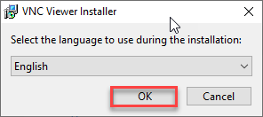

Then click on next

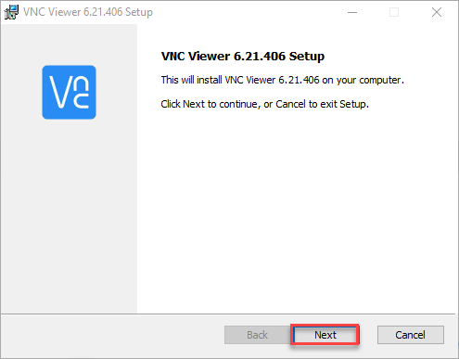

Click Accept Term Checkbox and click Next

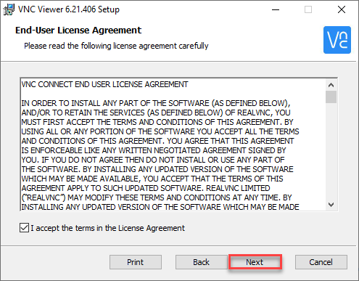

Click Next

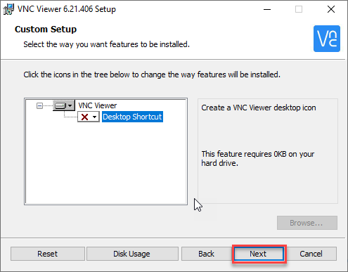

Click Install

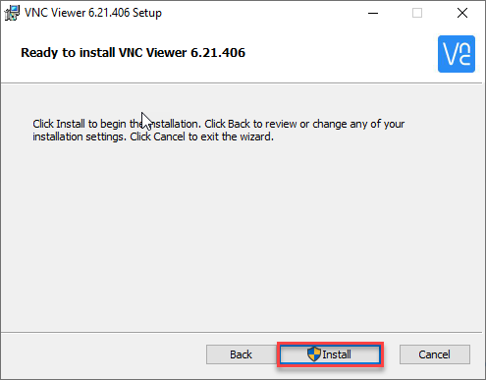

Click Finish

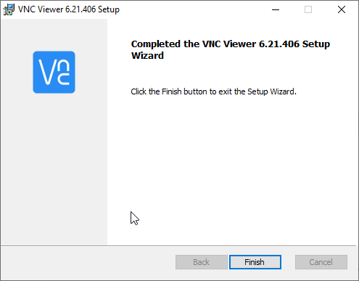

Open VNC Viewer App from the start

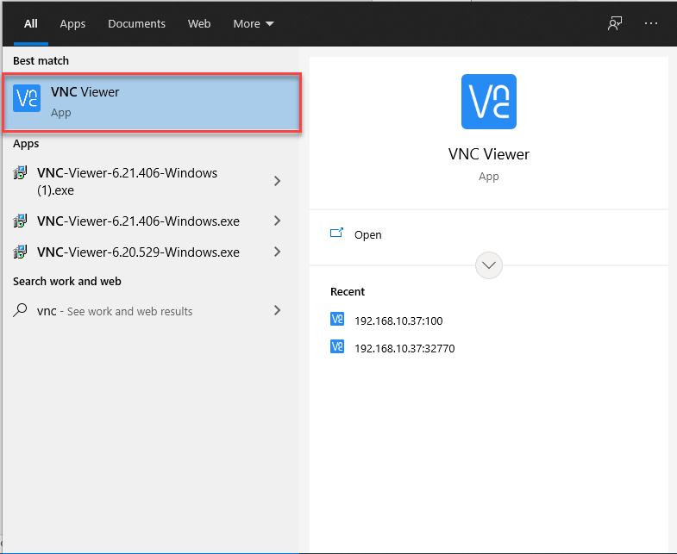

Enter the ip with the port number configured in .yml file and click enter

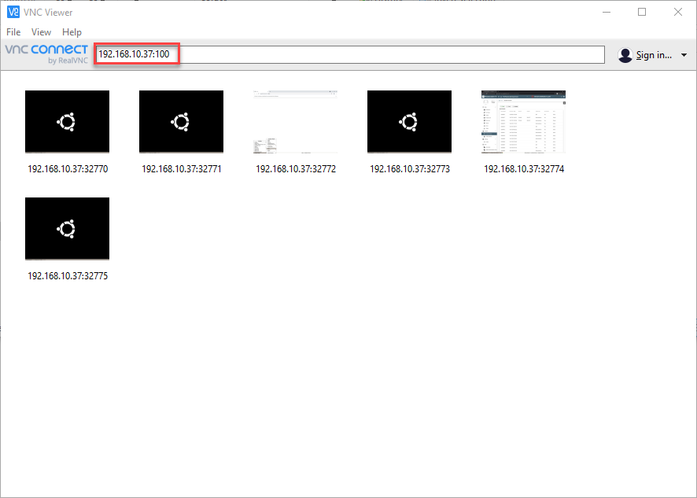

Click Don’t warn me check box and click Continue

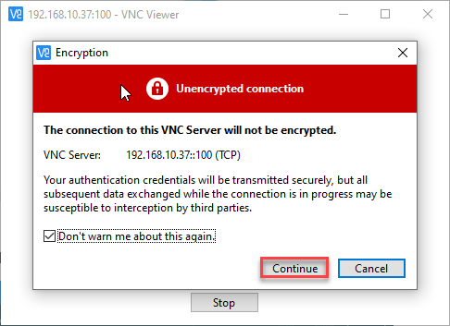

Enter the password and check remember password and click Ok, Password will be secret for all the port

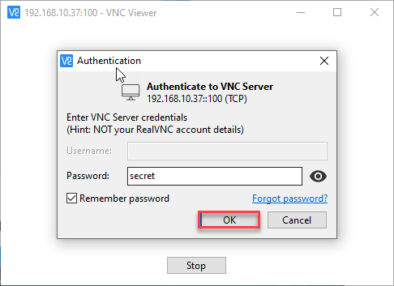

Once after clicking ok the following screen opens

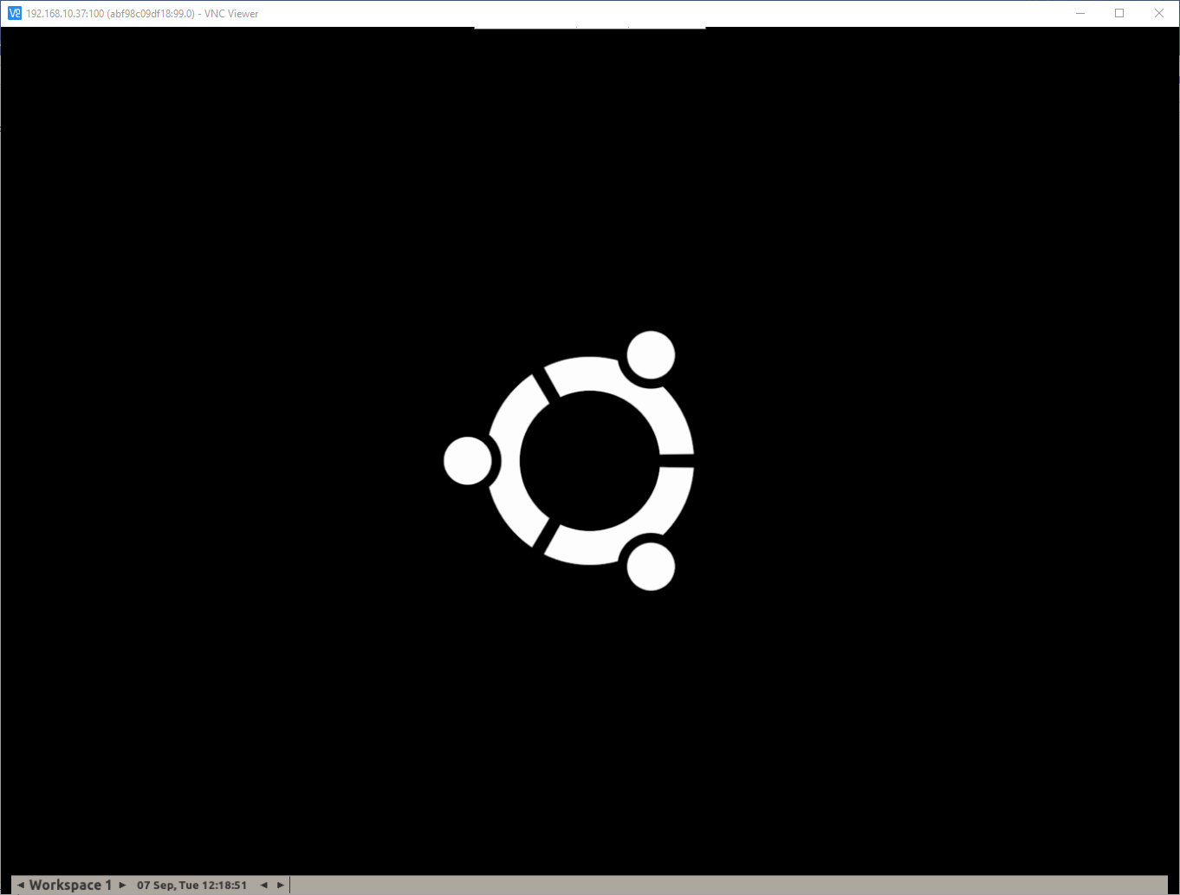

Once after we run the scripts in Eclipse we can view the scripts as seen below

